# 

Group 5

First Chance Saloon

Mary Cronin - 0510661

Adrian O Sullivan- 16230124

Deirdre Shanahan- 16230256

Cornelius Broderick - 9119124

# Introduction

This project will be to produce an online dating agency. The basic functionality will allow users to register and describe themselves, as well as browse other users and perform various searches (e.g. list all men over 25 who listed swimming as a hobby).

# High Level functionality

This website will support multiple users who are seeking a relationship. They will have two roles:

* Person initiating a contact
* Person receiving a request for a contact

The system will facilitate the communications between these two roles. The system will also support an administrator role whose function is to act as a mediator between users and will have the power to block or bar users. The system will monitor communications between users and automatically block messages that include inappropriate content.

Users will register their email address along with some personal details when setting up a new account. Once this is complete they will have access to do the following:

* Receive recommendations for people who match their profile
* Complete searches of the database to find people
* Communicate with other users
* Maintain account by updating profile, contact details or password
* Report inappropriate behaviour

For our website design we have chosen to take a minimalist approach in the number of questions being asked of the user. Based on our our research we have concluded that physical attractiveness plays a major part in initial encounters (Swami & Furnham, 2008). This website will be limited geographically to Ireland.

## User Stories

|  |  |  |  |
| --- | --- | --- | --- |
| *US001* | **User Profile** | *Priority* | **High** |
| *As A* | User | *Estimate* | Medium |
| *I would like* | To be able to register a user profile which includes a description of myself and indicating my preferences for a partner | | |
| *Because* | I am seeking a relationship with another person | | |
| *Acceptance Criteria* | * I can record the following details:   + Name   + Email   + Date of birth   + Gender   + Preferred Partner Gender   + Password   + Location (nearest City)   + Seeking Age Group   + Distance Will Travel   + Relationship Type   + Photo * I have the option of recording the following:   + Interests/Hobbies   + Bio * User can only create a profile if they are over the age of 18 * Passwords are ranked in order of secureness * Only one profile per email address supported | | |

|  |  |  |  |
| --- | --- | --- | --- |
| *US002* | **Profile Matching List** | *Priority* | **High** |
| *As A* | User | *Estimate* | High |
| *I would like* | To be able to search for specific criteria | | |
| *Because* | I would like to be able to complete broad searches for potential partners | | |
| *Acceptance Criteria* | * I can complete searches based on gender preference, age, hobbies or interests * I can find potential matches based on criteria above * The results are presented in photographic format. * I can indicate my interest in the listed profiles | | |

|  |  |  |  |
| --- | --- | --- | --- |
| *US001* | **Profile Matching List** | *Priority* | **High** |
| *As A* | User | *Estimate* | High |
| *I would like* | To be able to see people who are matched to my profile | | |
| *Because* | I would like to see a top 10 list of potential partners | | |
| *Acceptance Criteria* | * Based on my profile I can see a list of matching potential partners * Location is included in the ranking with a high weighting * I can view more details of a match and from there initiate contact * I can mark a potential match as “maybe”, Like (initiate request) or Goodbye profiles displayed * If I select a Goodbye, I am never presented with that profile again * This list is presented to me when I log in * I can report inappropriate behaviour | | |

|  |  |  |  |
| --- | --- | --- | --- |
| *US001* | **Initiate Request** | *Priority* | **High** |
| *As A* | User | *Estimate* | Medium |
| *I would like* | Initiate chat with a person | | |
| *Because* | I would like to be able to request a chat with a potential match | | |
| *Acceptance Criteria* | * I can establish a two way conversation with another user * I can see the chat history | | |

|  |  |  |  |
| --- | --- | --- | --- |
| *US001* | **Receive Request** | *Priority* | **High** |
| *As A* | User | *Estimate* | Low |
| *I would like* | To be able to see a list of requests from other users | | |
| *Because* | I need to see potential partners who are interested in meeting me | | |
| *Acceptance Criteria* | * List of requests are visible and I can view their profile | | |

|  |  |  |  |
| --- | --- | --- | --- |
| *US001* | **Moderation** | *Priority* | **High** |
| *As A* | System Administrator | *Estimate* | Low |
| *I would like* | To be able to oversee communications between users and block illegal or explicit content. | | |
| *Because* | The web site has a duty of care to their users | | |
| *Acceptance Criteria* | * A black list of words is maintained * Content containing black listed words is automatically blocked * The request will expire after a number of days * Option to report inappropriate content is available to users * Option to ban users from using the site | | |



|  |  |  |  |
| --- | --- | --- | --- |
| *US001* | **Moderation** | *Priority* | **High** |
| *As A* | System Administrator | *Estimate* | Low |
| *I would like* | Receive and process a notification of inappropriate behaviour from a user | | |
| *Because* | The web site has a duty of care to their users | | |
| *Acceptance Criteria* | * Users can be temporarily blocked from logging into the system for a period of time * User can be blocked from communicating with another specific user * User can be permanently blocked from using the system | | |

|  |  |  |  |
| --- | --- | --- | --- |
| *US001* | **Account destruction** | *Priority* | **High** |
| *As A* | User | *Estimate* | Low |
| *I would like* | To be able to request that my account is removed from the system | | |
| *Because* | GDPR compliance | | |
| *Acceptance Criteria* | * User details including all communications from that user are removed from the system | | |

|  |  |  |  |
| --- | --- | --- | --- |
| *US001* | **Password reset** | *Priority* | **High** |
| *As A* | User | *Estimate* | Low |
| *I would like* | To be able to reset my password | | |
| *Because* | I forgot my password | | |
| *Acceptance Criteria* | * Other users cannot reset my password | | |

|  |  |  |  |
| --- | --- | --- | --- |
| *US001* | **Security** | *Priority* | **High** |
| *As A* | System administrator | *Estimate* | Medium |
| *I would like* | To have security built into the website to prevent Denial of Service (Dos) and other forms of malicious code from being stored in the database | | |
| *Because* | I want to ensure availability of the website to our users | | |
| *Acceptance Criteria* | * SQL Injection attacks are blocked * Malicious code is prevented from being added to the database * Users cannot initiate any form on the site without first having a profile * Users must communicate using the HTTPS protocol (if this is possible using the UL site) | | |

## Data Flow Diagram

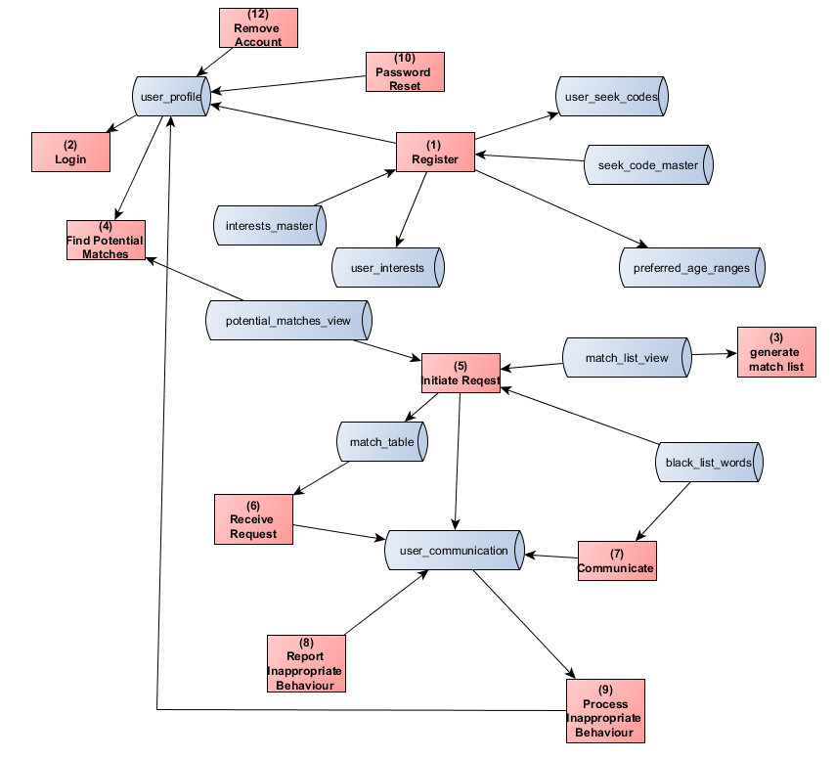

## Entity Relationship Diagram

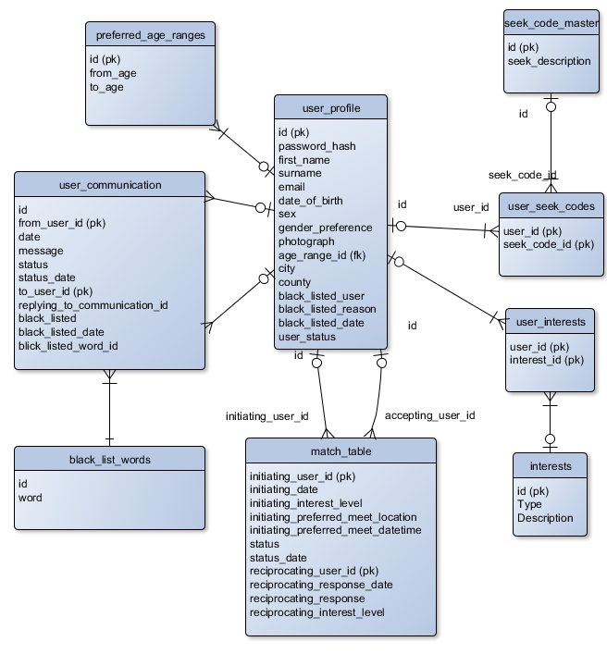

# Web Page Mock Ups

# Database Tables

Table 1 user_profile

|  |  |  |  |
| --- | --- | --- | --- |
| **Field** | **Type** | **Primary** | **Foreign** |
| id | int | Yes |  |
| password_hash | Varchar(200) |  |  |
| first_name | Varchar(50) |  |  |
| surname | Varchar(100) |  |  |
| email | Varchar(100) |  |  |
| date_of_birth | date |  |  |
| sex | bool |  |  |
| Gender_preference | Varchar(20) |  | yes |
| city | Varchar(100) |  |  |
| county | Varchar(100) |  |  |
| Black_listed_user | bool |  |  |
| Black_listed_reason | Varchar(100) |  |  |
| Black_listed_date | date |  |  |
| User_status | Varchar(50) |  |  |

Table 2 match_table

|  |  |  |
| --- | --- | --- |
| **Field** | **Type** | **Primary** |
| Initiating_user_id | int | yes |
| Initiation_date | datetime |  |
| Initiation_interest_level | int |  |
| Initiation_prefered_meeting_location | Varchar(100) |  |
| Initiating_preferred_meet_datetime | datetime |  |
| status | Varchar(20) |  |
| Status_date | datetime |  |
| Reciprocating_user_id | int | yes |
| Reciprocatin_response_date | datetime |  |
| Reciprocating_response | Varchar(2000) |  |
| Reciprocating_interest_level | int |  |

Table 3 user_communication

|  |  |  |
| --- | --- | --- |
| **Field** | **Type** | **Primary** |
| id | int |  |
| from_user_id | int | yes |
| date | datetime |  |
| message | Varchar(150) |  |
| status | Varchar(20) |  |
| To_user_id | int |  |
| Replying_to_communication_id | int |  |
| Black_listed | bool |  |
| Black_listed_date | datetime |  |
| Black_listed_word_id | int |  |

Table 4 perferred_age_ranges

|  |  |  |
| --- | --- | --- |
| **Field** | **Type** | **Primary** |
| id | int | yes |
| From_age | int |  |
| to_age | int |  |

Table 5 black _list_words

|  |  |  |
| --- | --- | --- |
| **Field** | **Type** | **Primary** |
| id | int | yes |
| word | Varchar(100) |  |

Table 6 user_interests

|  |  |  |
| --- | --- | --- |
| **Field** | **Type** | **Primary** |
| User_id | int | yes |
| Interest_id | int | yes |

Table 7 interests

|  |  |  |
| --- | --- | --- |
| **Field** | **Type** | **Primary** |
| id | int | yes |
| type | Varchar(100) |  |
| description | Varchar(200) |  |

Table 7 Gender Table

|  |  |  |
| --- | --- | --- |
| **Field** | **Type** | **Primary** |
| id | int | yes |
| city | Varchar(200) |  |

Table 8 city Table

|  |  |  |
| --- | --- | --- |
| **Field** | **Type** | **Primary** |
| id | int | yes |
| city | Varchar(200) |  |
| county | Varchar(200) |  |

Table 9 Relationship Type

|  |  |  |
| --- | --- | --- |
| **Field** | **Type** | **Primary** |
| id | int | yes |
| Relationship_type | Varchar(200) |  |

Table 10 Status

|  |  |  |
| --- | --- | --- |
| **Field** | **Type** | **Primary** |
| id | int | yes |
| status | Varchar(200) |  |

# Process List:

High level Flowchart of Dating W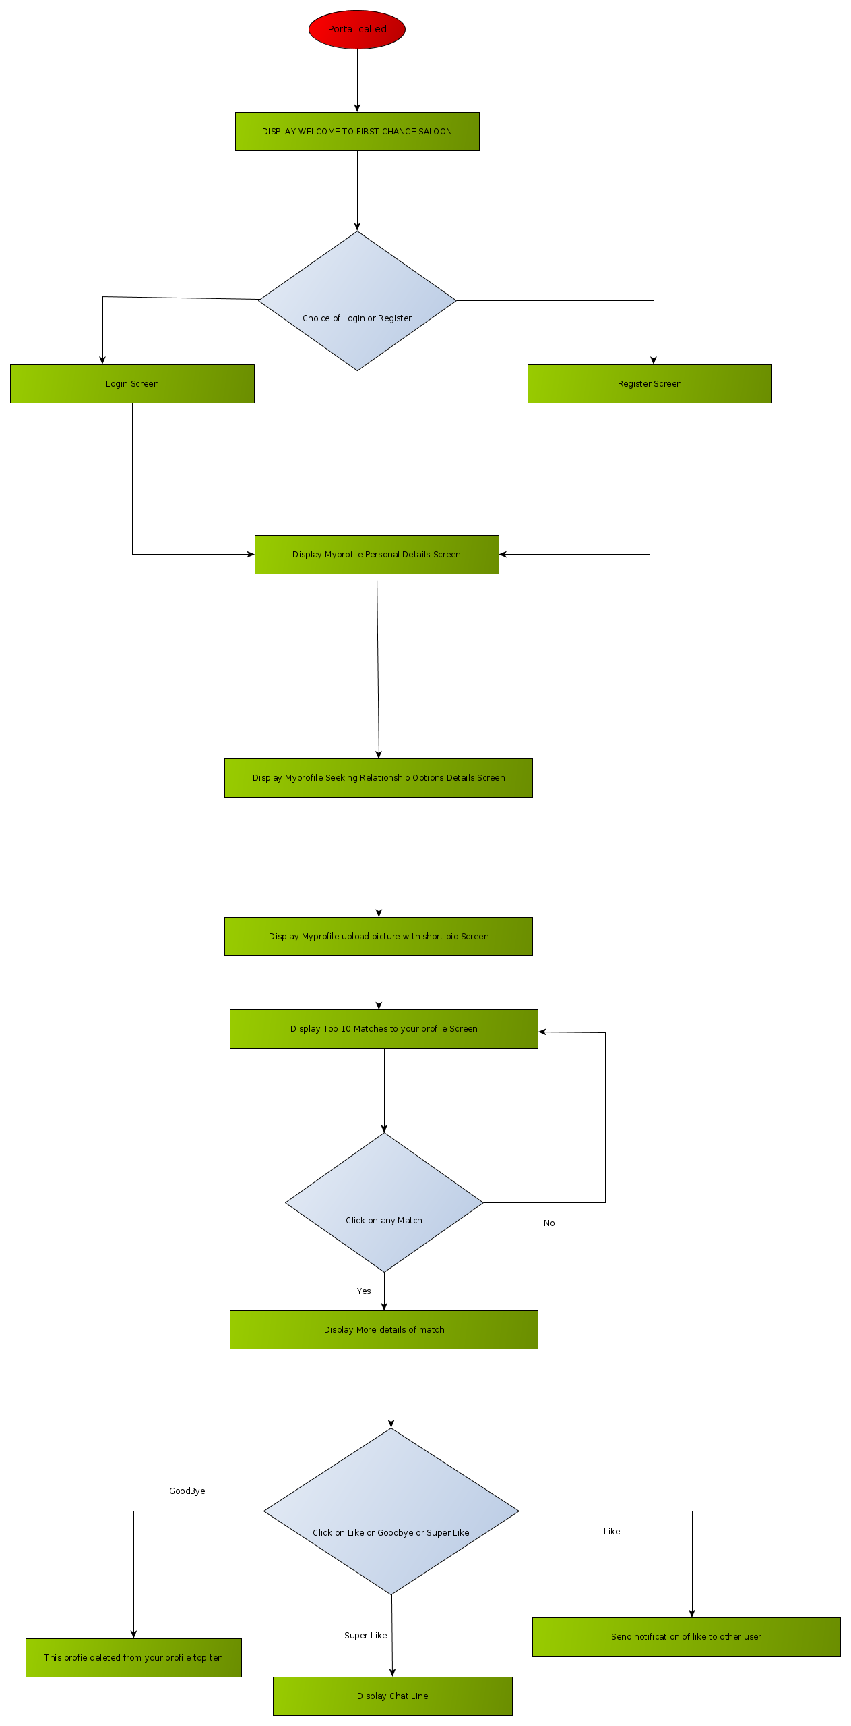eb site

Process List

Use Case System and Activity Diagram of Web dating site

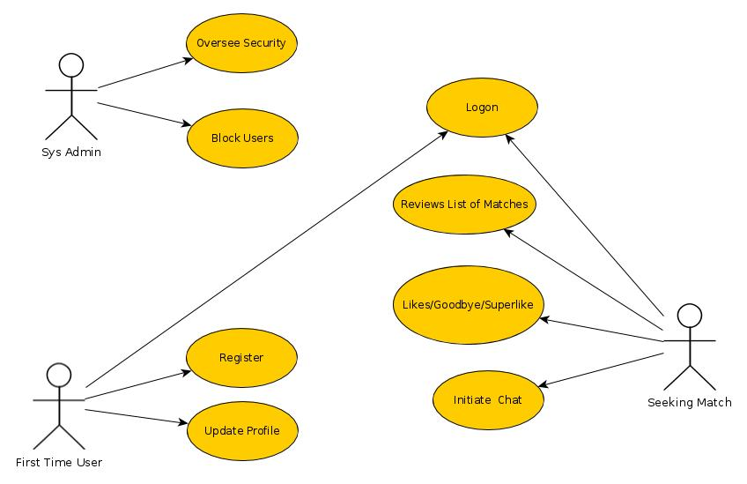

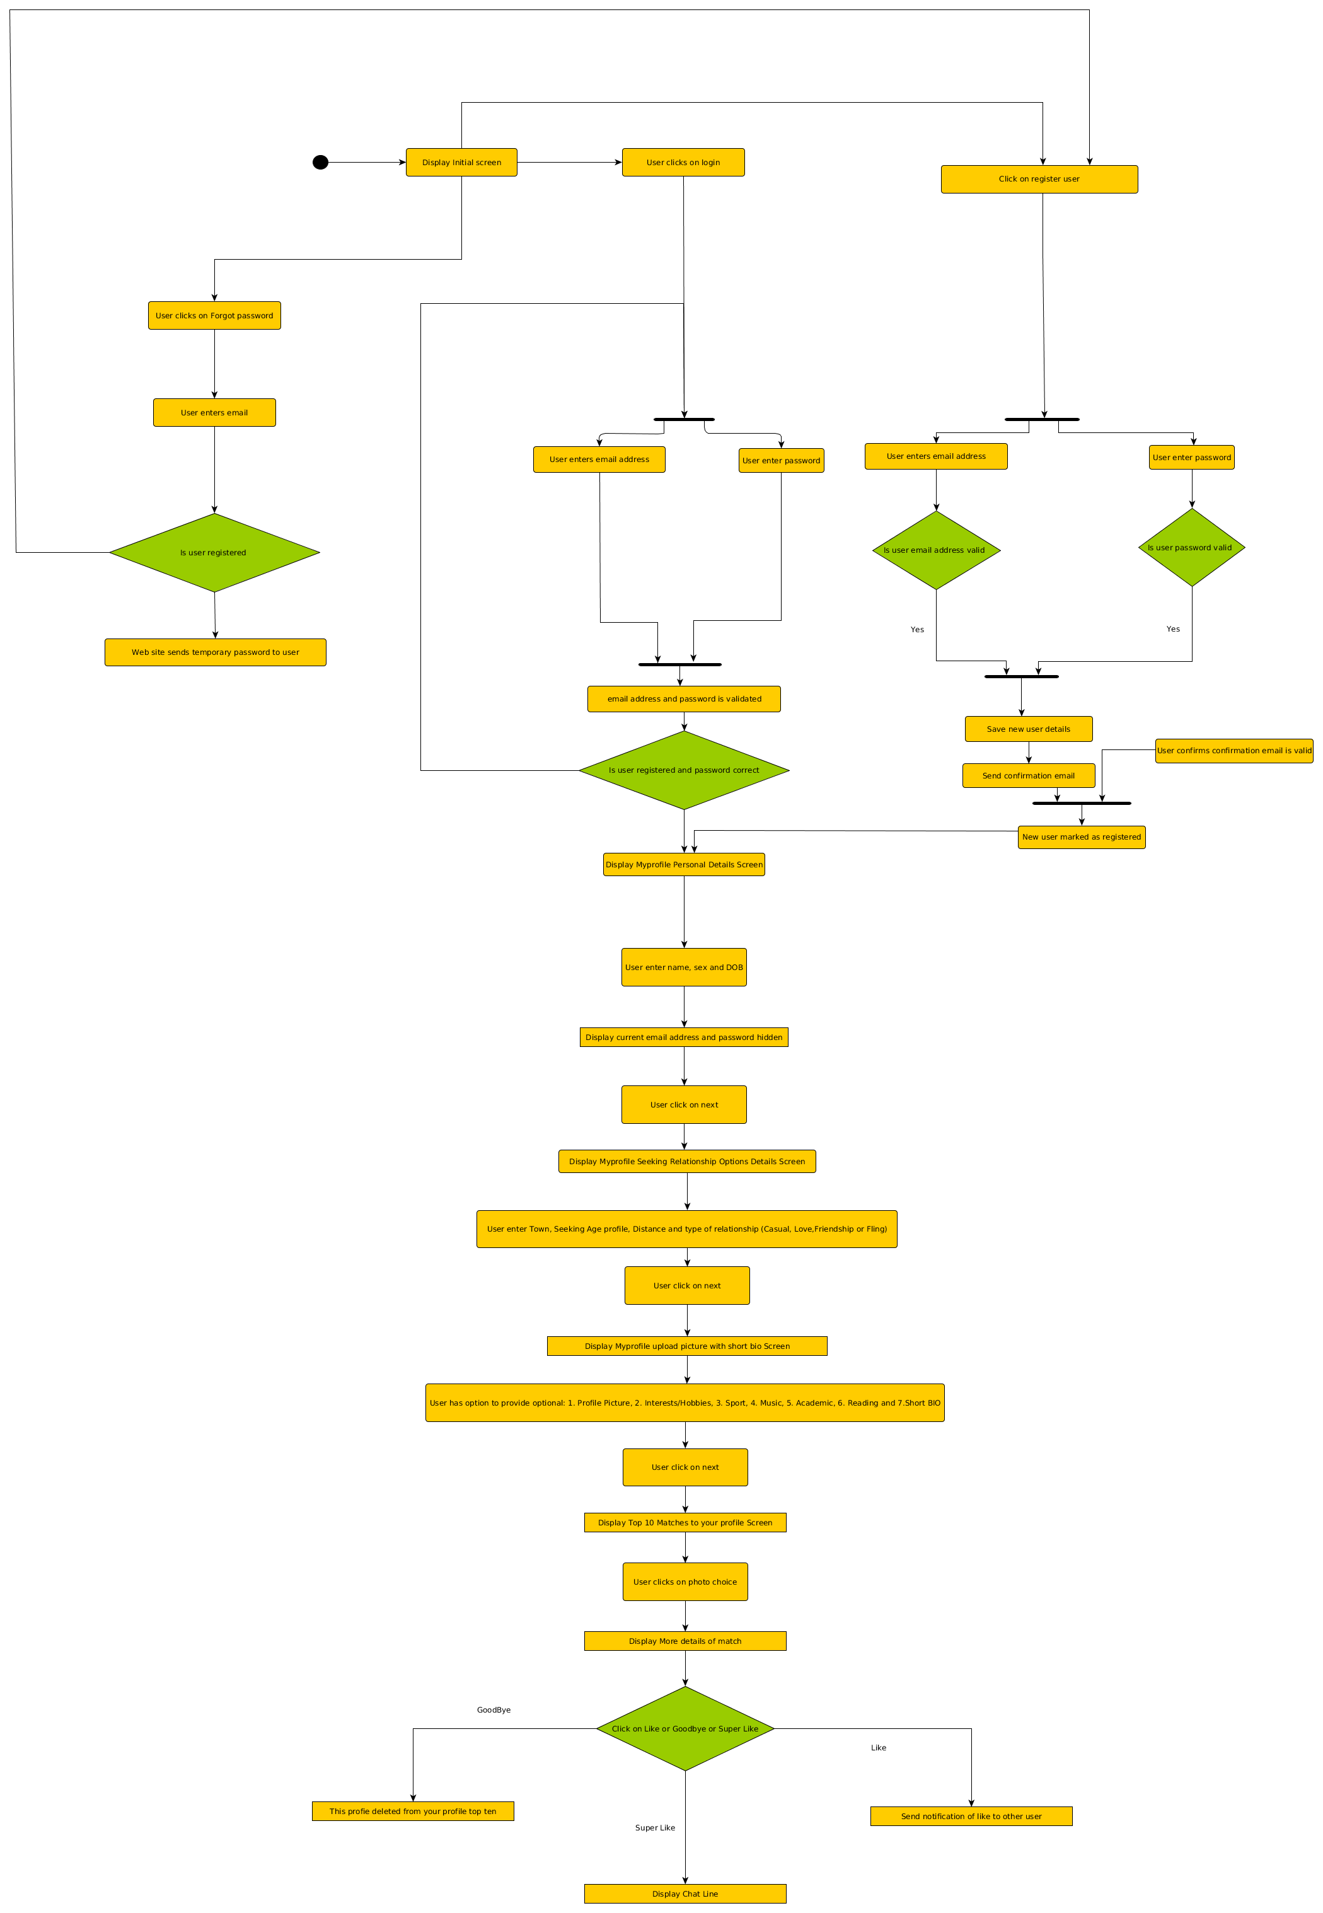

High level functionality

|  |  |
| --- | --- |
| Process # | **1** |
| Title | To be able to register a user profile which includes a description of myself and indicating my preferences for a partner |
| Brief Description | I am seeking a relationship with another person |
| Inputs | * Name * Email * Date of birth * Sex * Preferred Partner sex * Password * Location (nearest Town) * Photo * I have the option of recording the following:   + Interests   + Hobbies   + Type of relationship   + Age profile of partner   + User can only create a profile if they are over the age of 18   + Passwords are ranked in order of secureness   + Only one profile per email address  supported |
| Detailed Description |  |
| Output |  |

|  |  |
| --- | --- |
| Process# | **2** |
| Title | To be able to search for specific criteria |
| Brief Description |  |
| Inputs |  |
| Detailed Description | I would like to be able to complete broad searches for potential partners |
| Output | * I can complete searches based on sexual preference, age, hobbies or interests * I can find all potential matches based on criteria above * The information listed provides enough information to make an informed selection * I can sort the list by different headings |

|  |  |
| --- | --- |
| Process # | **3** |
| Title | Users matched to my preferences |
| Brief Description | To be able to see a list of people who are matched to my preferences with a scale showing their percentage match which includes location |
| Inputs |  |
| Detailed Description | * Based on my preferences I can see a list of matching potential partners * Location is included in the ranking with a high weighting * I can find people who are well suited to my preferences and interests * I can Like, Super Like (initiate request) or Goodbye profiles displayed * This list is presented to me when I log in. |
| Output | * list of potential partners which is ranked based on my likes and location |

|  |  |
| --- | --- |
| Process # | **4** |
| Title | "SuperLike" a match |
| Brief Description | Initiate “SuperLilke”  meeting with a person listed on my match list |
| Inputs | Found a match - based on web site algorithm or user selection  I would like to be able to request a meeting with a potential match |
| Detail Description | * When I make a request to meet a person, I can see a limited set of details from their profile * When I make a request, that person can see a limited set of details from my profile * The request will expire after a number of days |
| Output | * Matched user is notified of a "Superlike" |

|  |  |
| --- | --- |
| Process # | **5** |
| Title | List of invitations from other user |
| Brief Description | To be able to see a list of requests from other users |
| Inputs | I need to see potential partners who are interested in meeting me |
| Detailed Description | * List of requests are visible and my match ranking is included * I can Like, "SuperLike" or Goodbye or request additional information * When I receive a request, that person can see a limited set of details from my profile * If I accept a request, I can see more information on the user |
| Output | * Managed requests from other users |

|  |  |
| --- | --- |
| Process # | **6** |
| Title | System Administrator privileges |
| Brief Description | To be able to oversee communications between users and block illegal or explicit content. |
| Inputs | The web site has a duty of care to their users |
| Detailed Descriptions | * A black list of words is maintained * Content containing black listed words is automatically blocked * The request will expire after a number of days * Option to report inappropriate content is available to users * Option to ban users from using the site |
| Output | * A super user account is created able to perform desired actions |

|  |  |
| --- | --- |
| Process # | **7** |
| Title | System administrator blocking feature |
| Brief Description | Notify the system administrator of inappropriate behaviour |
| Inpute | I would like to be protected from other user’s behaviour when I take offence |
| Detailed Description | * A notification of bad behaviour can be initiated by the user * The user is notified of the actions taken by the administrator |
| Output | * User blocked due to inappropriate behaviour |

|  |  |
| --- | --- |
| Process # | **8** |
| Title | System Administrator receives request to stop other users inappropriate behaviour |
| Brief description | Receive and process a notification of inappropriate behaviour from a user |
| Inputs | The web site has a duty of care to their users |
| Detailed Description | * Users can be temporarily blocked from logging into the system for a period of time * User can be blocked from communicating with another specific user * User can be permanently blocked from using the system |
| Output | * System administrator is notified of inappropriate behaviour |

|  |  |
| --- | --- |
| Process # | **9** |
| Title | User able  to delete their own account |
| Brief description | To be able to request that my account is removed from the system |
| Inputs | * User chooses to delete their account |
| Detailed Description | * User details including all communications from that user are removed from the system |
| Output | * GDPR compliance |

|  |  |
| --- | --- |
| Process # | **10** |
| Title | Password reset |
| Brief Description | * To be able to reset my password |
| Inputs | * User clicks on  forgot my password |
| Detailed Description | * Other users cannot reset my password |
| Output | * User safely resets their own passwords |

|  |  |
| --- | --- |
| Process # | **11** |
| Title | Web site security |
| Brief Description | To have security built into the website to prevent Denial of Service (Dos) and other forms of malicious code from being stored in the database |
| Inputs | I want to ensure availability of the website to our users |
| Detailed Description | * SQL Injection attacks are blocked * Malicious code is prevented from being added to the database * Users cannot initiate any form on the site without first having a profile * Users must communicate using the HTTPS protocol (if this is possible using the UL site) |
| Output | * Only https connections are available |

# Bibliography

Swami, V., & Furnham, A. (2008). *The psychology of physical attraction*. New York, NY: Routledge/Taylor & Francis Group.